

**PES UNIVERSITY**

**(Established under Karnataka Act No. 16 of 2013)**

**100-ft Ring Road, Bengaluru – 560 085, Karnataka, India**

***Report on Mini Project***

**‘IR BASED TRAFFIC DENSITY DETECTOR AND SIGNAL ADJUSTOR’**

***Submitted by***

**HARSHITA R VASTRAD ( PES1201701717)**

**AAKANSHA MISHRA (PES1201700422)**

**SHRUTI SHEKHAR SINGH (PES1201700439)**

**Jan. - May 2019**

**under the guidance of**

**Dr. Anuradha M**

**Professor and Chairperson**

**Department of ECE**

**PES University**

**Bengaluru -560085**



**CERTIFICATE**

This is to certify that the Report entitled

**‘IR BASED TRAFFIC DENSITY DETECTOR AND SIGNAL ADJUSTOR’**

*is a bonafide work carried out by*

**HARSHITA R VASTRAD ( PES1201701717)**

**AAKANSHA MISHRA (PES1201700422)**

**SHRUTI SHEKHAR SINGH (PES1201700439)**

In partial fulfillment for the completion of 4th semester Special Topic Mini Project in the Program of Study B.Tech in Electronics and Communication Engineering under rules and regulations of PES University, Bengaluru during the period Jan – May. 2019. It is certified that all corrections/suggestions indicated for internal assessment have been incorporated in the report. The report has been approved as it satisfies the 4th semester academic requirements in respect of project work.

*Signature with date & Seal Signature with date & Seal*

*Internal Guide Chairperson*

*Name/s of the student/s* **HARSHITA R VASTRAD – PES1201701717**

**AAKANSHA MISHRA – PES1201700422**

**SHRUTI SHEKHAR SINGH – PES1201700439**

Name of the examiners:

1.

2.

**DECLARATION**

We, Harshita R Vastrad**,** Shruti Shekhar Singh and Aakansha Mishra hereby declare that the report entitled, ‘***Traffic density detector and signal adjustment’,*** is an original work done by us under the guidance of **Dr. Anuradha M,Professor and Chairperson ECE Department,PESU**, and is being submitted in partial fulfillment of the requirements for completion of 4th Semester 2 credit Course / Mini Project in the Program of Study B.Tech in Electronics and Communication Engineering.

**PLACE:**

**DATE:**

**NAME AND SIGNATURE OF THE CANDIDATES**

**1.ABSTRACT**

Nowadays, controlling the traffic becomes major issue because of rapid increase in automobiles and also because of large time delays between traffic lights. So, in order to rectify this problem, we will go for density based traffic lights system. This article explains you how to control the traffic based on density.

In this system, we will use IR sensors to measure the traffic density. We have to arrange one IR sensor for each road, these sensors always sense the traffic on that particular road. All these sensors are interfaced to the arduino. Based on these sensors,arduino detects the traffic and controls the traffic system.

**2.INTRODUCTION:**

A steady increase in metro-city population, the number of automobiles and cars increases rapidly and metro traffic is growing crowded which leads to the traffic jam problem. Nowadays, controlling the traffic becomes major issue because of rapid increase in automobiles and also because of large time delays between traffic lights. So, in order to rectify this problem, we will go for density based traffic lights system. This article explains you how to control the traffic based on density.

In this system, we will use IR sensors to measure the traffic density. We have to arrange one IR sensor for each road, these sensors always sense the traffic on that particular road. All these sensors are interfaced to the arduino. Based on these sensors, controller detects the traffic and controls the traffic system.

**2.1 RESEARCH OBJECTIVE:**

The main purpose of introducing this smart traffic system is that for every minute the vehicles at the junction will be dense and the traffic lights shall be changed to each side for some fixed time. Even though there are no vehicles at particular side, the traffic signals will glow for a given fixed time. Due to that there is time wastage & vehicles on the other side have to wait for the time to complete the process. So to reduce the wastage of time, we can implement the system that controls the traffic based on the heavy flow of vehicles at any particular side. With this system, we shall count the number of vehicles at each side at the junction and give path to the particular side which has denser traffic and keeping the other sides stopped.

**2.2 LITERATURE REVIEW:**

Currently the vehicle problem is increasing and Traffic congestion is a severe problem in many modern cities all over the world. To overcome the problem, we have come up with the idea of Density based traffic light control system. Traffic research has the goal to optimize traffic flow, as roads have been overloaded with the increasing number of vehicles. There are several models which give solutions for traffic simulation. In our research we have focused on controlling the traffic lights on the bases of traffic density. Nowadays congestion in traffic is a serious issue.The traffic congestion can also be caused by large Red light de-lays, etc. The delay of respective light is

hard coded in the traffic light and it is not dependent on traffic. Thus I propose multiple traffic light control system.

The system tries to reduce possibilities of traffic jams, caused by traffic lights, to an extent.

The system contains IR transmitter and IR receiver which are mounted on the either sides of roads respectively. The IR system gets activated when ever any vehicle passes on road between IR transmitter and IR receiver. In this system IR sensors are used to measure the density of the vehicles which are fixed within a fixed distance. The sensors continuously keep sensing density on all sides and the green signal is given on priority basis, where the sensors detect high density. The side with next priority level follows the first priority level. By using this system traffic can be cleared without irregularities and time delay when there is no traffic on the other side can be avoided.

**3.PROBLEM STATEMENT**

The high volume of vehicles, the inadequate infrastructure and the irrational distribution of the development are main reasons for increasing traffic jam. The major cause leading to traffic congestion is the high number of vehicle which was caused by the population and the development of economy.

Traffic congestion is a condition on road networks that occurs as use increases, and is characterized by slower speeds, longer trip times, and increased vehicular queuing.

The most common example is the physical use of roads by vehicles. When traffic demand is great enough that the interaction between vehicles slows the speed of the traffic stream, these results in some congestion .As demand approaches the capacity of a road (or of the intersections along the road), extreme traffic congestion sets in. When vehicles are fully stopped for periods of time, this is colloquially known as a traffic jam or traffic snarl-up. Traffic congestion can lead to drivers becoming frustrated and engaging in road rage. In order to avoid the congestion in the traffic. In traffic environments, Traffic Sign Recognition (TSR) is used to regulate traffic signs, warn the driver, and command or prohibit certain actions. A fast real-time and robust automatic traffic sign detection and recognition can support and disburden the driver, and thus, significantly increase driving safety and comfort. Generally, traffic signs provide the driver various information for safe and efficient navigation Automatic recognition of traffic signs is, therefore, important for automated intelligent driving vehicle or driver assistance systems.

**4.BASIC LAYOUT OF TRAFFIC CONTROL SYSTEM**

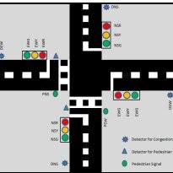

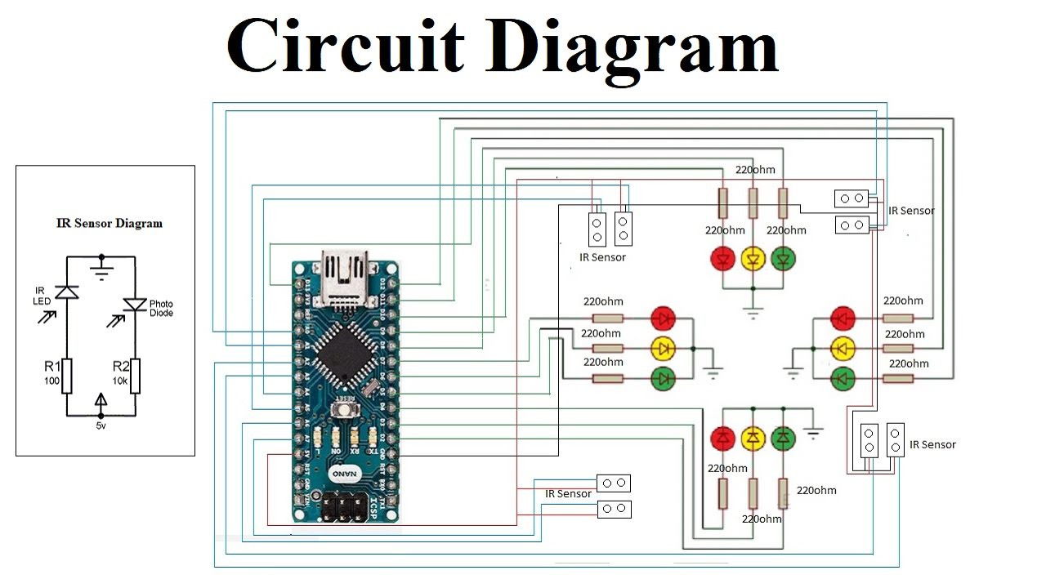

**5.METHODOLOGY:**

• The system is based on microcontroller.

• The system contains IR transmitters and IR receivers which are mounted on the either sides of roads.

• This IR system gets activated when any vehicle passes on road between IR transmitter and IR receiver.

• The microcontroller controls the IR system and gets activated when vehicles are passing in between the sensors.

**6.HARDWARE DESCRIPTION**

**6.1.ARDUINO NANO**

It is a Microcontroller board developed by Arduino.cc and based on Atmega328p / Atmega168.

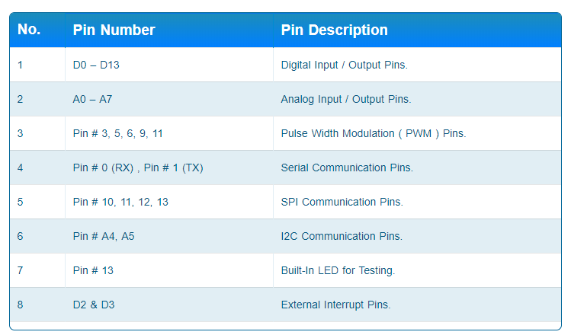

* **Arduino Nano** is a small, compatible, flexible and breadboard friendly Microcontroller board, developed by Arduino.cc in Italy, based on ATmega328p ( Arduino Nano V3.x)  / Atmega168 ( Arduino Nano V3.x).
* It comes with exactly the same functionality as in Arduino UNO but quite in small size.
* It comes with an operating voltage of 5V, however, the input voltage can vary from 7 to 12V.
* **Arduino Nano Pinout** contains 14 digital pins, 8 analog Pins, 2 Reset Pins & 6 Power Pins.
* Each of these Digital & Analog Pins are assigned with multiple functions but their main function is to be configured as input or output.
* They are acted as input pins when they are interfaced with sensors, but if you are driving some load then use them as output.
* Functions like pinMode() and digitalWrite()  are used to control the operations of digital pins while analogRead() is used to control analog pins.
* The analog pins come with a total resolution of 10bits which measure the value from zero to 5V.
* Arduino Nano comes with a crystal oscillator of frequency 16 MHz. It is used to produce a clock of precise frequency using constant voltage.
* There is one limitation using Arduino Nano i.e. it doesn’t come with DC power jack, means you can not supply external power source through a battery.
* This board doesn’t use standard USB for connection with a computer, instead, it comes with Mini USB support.
* Tiny size and breadboard friendly nature make this device an ideal choice for most of the applications where a size of the electronic components are of great concern.
* Flash memory is 16KB or 32KB that all depends on the Atmega board i.e Atmega168 comes with 16KB of flash memory while Atmega328 comes with a flash memory of 32KB. Flash memory is used for storing code. The 2KB of memory out of total flash memory is used for a bootloader.

[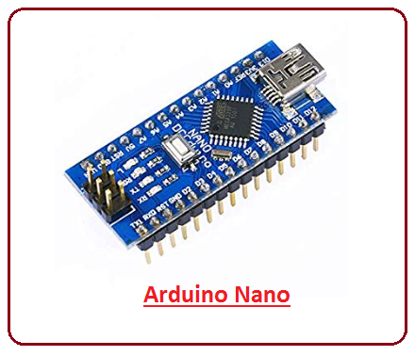](https://www.theengineeringprojects.com/wp-content/uploads/2018/06/introduction-to-arduino-nano-5.png)

* The SRAM can vary from 1KB or 2KB and EEPROM is 512 bytes or 1KB for Atmega168 and Atmega328 respectively.
* This board is quite similar to other Arduino boards available in the market, but the small size makes this board stand out from others.
* Following figure shows the specifications of Arduino Nano Board.

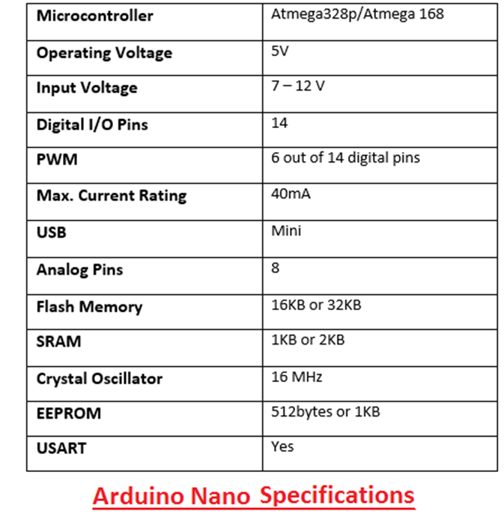

* It is programmed using Arduino IDE which is an Integrated Development Environment that runs both offline and online.
* No prior arrangements are required to run the board. All you need is board, mini USB cable and Arduino IDE software installed on the computer. USB cable is used to transfer the program from computer to the board.
* No separate burner is required to compile and burn the program as this board comes with a built-in boot-loader.

**6.1.1ARDUINO NANO PINOUT**

Following figure shows the pinout of Arduino Nano Board.

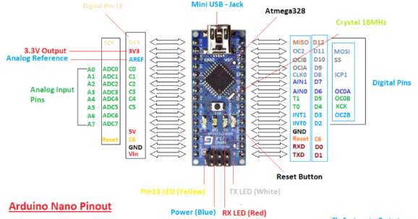

* Each pin on the Nano board comes with a specific function associated with it.
* We can see the analog pins that can be used as an analog to digital converter where A4 and A5 pins can also be used for I2C communication. Similarly, there are 14 digital pins, out of which 6 pins are used for generating PWM.

6.1.2 **PIN DESCRIPTION**

**Vin.** It is input power supply voltage to the board when using an external power source of 7 to 12 V.

[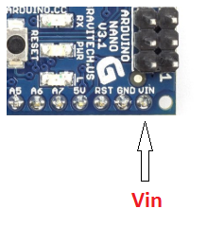](https://www.theengineeringprojects.com/wp-content/uploads/2018/06/introduction-to-arduino-nano-6.png)  
**5V.** It is a regulated power supply voltage of the board that is used to power the controller and other components placed on the board.

[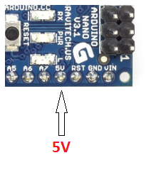](https://www.theengineeringprojects.com/wp-content/uploads/2018/06/introduction-to-arduino-nano-7.png)

**3.3V.** This is a minimum voltage generated by the voltage regulator on the board.

[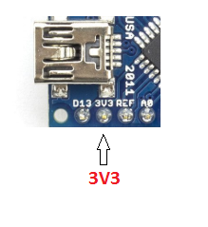](https://www.theengineeringprojects.com/wp-content/uploads/2018/06/introduction-to-arduino-nano-8.png)

**GND.** These are the ground pins on the board. There are multiple ground pins on the board that can be interfaced accordingly when more than one ground pin is required.

[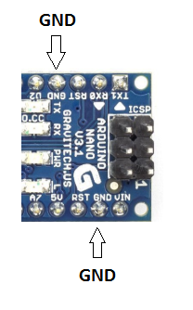](https://www.theengineeringprojects.com/wp-content/uploads/2018/06/introduction-to-arduino-nano-9.png)

**Reset.** Reset pin is added on the board that resets the board. It is very helpful when running program goes too complex and hangs up the board. LOW value to the reset pin will reset the controller.

[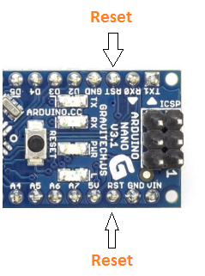](https://www.theengineeringprojects.com/wp-content/uploads/2018/06/introduction-to-arduino-nano-10.png)

**Analog Pins.** There are 8 analog pins on the board marked as A0 – A7. These pins are used to measure the analog voltage ranging between 0 to 5V.

[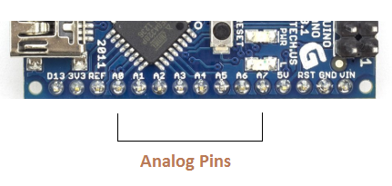](https://www.theengineeringprojects.com/wp-content/uploads/2018/06/introduction-to-arduino-nano-11.png)

**Rx, Tx.** These pins are used for serial communication where Tx represents the transmission of data while Rx represents the data receiver.

[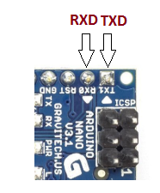](https://www.theengineeringprojects.com/wp-content/uploads/2018/06/introduction-to-arduino-nano-12.png)

**13.** This pin is used to turn on the built-in LED.

**AREF.** This pin is used as a reference voltage for the input voltage.

**PWM.** Six pins 3,5,6,9,10, 11 can be used for providing 8-pit PWM (Pulse Width Modulation) output. It is a method used for getting analog results with digital sources.

**SPI.** Four pins 10(SS),11(MOSI),12(MISO),13(SCK) are used for SPI (Serial Peripheral Interface). SPI is an interface bus and mainly used to transfer data between microcontrollers and other peripherals like sensors, registers, and SD card.

**External Interrupts.** Pin 2 and 3 are used as external interrupts which are used in case of emergency when we need to stop the main program and call important instructions at that point. The main program resumes once interrupt instruction is called and executed.

**I2C.** I2C communication is developed using A4 and A5 pins where A4 represents the serial data line (SDA) which carries the data and A5 represents the serial clock line (SCL) which is a clock signal, generated by the master device, used for data synchronization between the devices on an I2C bus.

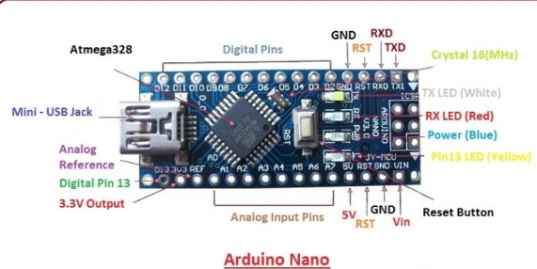

**6.2.IR SENSOR**

IR (INFRARED) sensor is based on LM 358 IC which is an Operational amplifier acting as comparator.

The comparator compares the analog voltages of potentiometer and the vol tage generated by the photodiode.

The two voltages are applied on the two terminals of the IC and correspondingly it generates a digital output on the output pin that is indicated by a Red Led.The IR sensor is compatible with various microcontroller boards like 8051, Arduino, pic etc.

This shield is based on the working of a circuit comprising op-amp, an IR led and photodiode the output generate by the sensor is due the comparator action of the opamp (LM358). The Compares the two voltages that is generated by the photodiode and the potentiometer. When the value of voltage Vd generated by photodiode is greater than the voltage set on the potentiometer, the output is HIGH and vice versa.

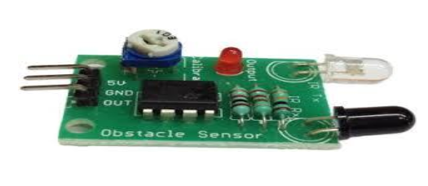

**Technical Specifications:**

2-12cm range

Potentiometer for maximum range setting.

Can be used to differentiate between black and white (Can be used for line sensing) .

Onboard LED indication for detection

Works on 5V input.

TTL compatible output .

LM358 IC (Integrated Circuit) that acts as a comparator/ ADC (Analog to Digital Converter) IC which makes it digital sensor. 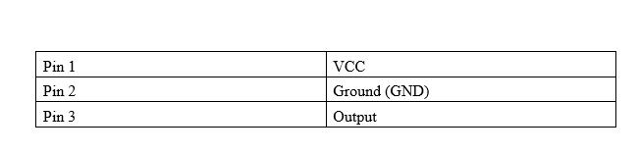

**6.3.LED**

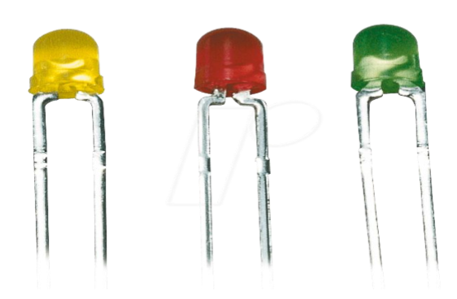

A light-emitting diode (LED) is a two-lead semiconductor HYPERLINK light source. It is a pn junction HYPERLIN diode, which emits light when activated. When a suitable voltage is applied to the leads, electrons are able to recombine with electron holes within the device, releasing energy in the form of photons. This effect is called electroluminescence, and the color of the light (corresponding to the energy of the photon) is determined by the energy band gap of the semiconductor.

**6.4.RESISTOR**

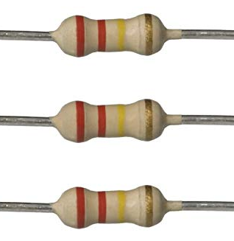

The electrical resistance of an electrical conductor is the opposition to the passage of an electric current through that conductor. The inverse quantity is electrical conductance, the ease with which an electric current passes. Electrical resistance shares some conceptual parallels with the notion of mechanical friction. The SI unit of electrical resistance is the ohm (Ω), while electrical conductance is measured in siemens (S). An object of uniform cross section has a resistance proportional to its resistivity and length and inversely proportional to its cross-sectional area. All materials show some resistance, except for superconductors, which have a resistance of zero.

**7.SOFTWARE DESIGN AND HARDWARE RESULT**

**Getting Started with Arduino Nano**

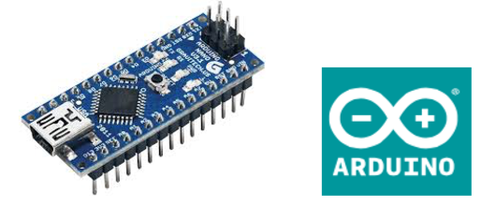

The Arduino Nano is a simple 8-bit microcontroller, ideal for beginners and simple embedded projects. It is programmed via USB and has a number of I/O pins. It uses the Atmel ATmega 328P microprocessor chip.

1. Install the required device driver Several clone versions of the Nano are around, so you may have to try several device drivers for your Mac or PC: Win: http://robotics.ee.uwa.edu.au/nano/drivers/win/ Mac: http://robotics.ee.uwa.edu.au/nano/drivers/mac/

2. Install the Arduino programming environment Download and install the latest Arduino Software from this site: Win or Mac: https://www.arduino.cc/en/Main/Software The Arduino Software allows some simple programming in a reduced C-like language. Once familiar with this system, you can also download the Atmel Studio / GNU programming tools for programming in assembly or C (Atmel is the manufacturer of the microprocessor).

These are available for Windows only:

Win: <http://www.atmel.com/tools/atmelstudio.aspx>

Win: <http://sourceforge.net/projects/winavr/files/>

or:

http://robotics.ee.uwa.edu.au/nano/win/

3. Connect your Arduino Nano via the USB cable to your Mac/PC The power light should come on. (Different hardware versions use differently colored LEDs)

4. Start the Arduino Software • Under Tools / Board select: Arduino Nano • Under Tools / Processor select: ATMega328 • Under Port select Mac: something like /dev/cu.usbserial.ABCDEFGH Win: correct COM port Selecting the correct USB port can be tricky and will only work if the correct driver has been installed. Without the right port, you cannot upload software to the Nano.

5. Select an Example Program Select menu item File / Examples / 01. Basics / Blink The example program will occur in the editor window. Note that each program has two functions: setup and loop. So after an initial setup at start time (e.g. power-up), every program will run in an endless loop (until you disconnect power or overwrite it). This is how all embedded systems work.

6. Compile the Example Program Compile the program by clicking on the tick button (✓) in the top left corner of the window. A message should appear that says “Done compiling”, without any error messages.

7. Upload the Executable Program to the Nano Click on the arrow button (è) on top, second from left. You will get the message “Uploading” with a progress bar and finally “Done uploading”. The program will be stored permanently in the Nano’s flash memory. It will remain there, even if you disconnect power and reconnect it later, until you eventually overwrite it with another program. If you get a red error message, then check your settings (step 4) or go back to driver installation

10. Add Input / Output The important next step is to add I/O to the controller. See the diagram for all available I/O lines.

**7.1 PCB DESIGNING PROCESS**

It is used to mechanically support and electrically connect Electrical component using conductive pathways, tracks or signal traces etched from copper sheets laminated onto a nonconductive substrate. It is also referred to as printed wiring board (PWB) or etched wiring board. A PCB populated with electronic components is a printed circuit assembly (PCA), also known as a printed circuit board assembly (PCBA). Printed circuit boards are used in virtually all but the simplest commercially-produced electronic devices. PCBs are inexpensive, and can be highly reliable. They require much more layout effort and higher initial cost than either wire wrap or point-to-point construction, but are much cheaper and faster for high volume production and soldering od PCBs can be done by totally automated equipment. Much of the electronics industry’s PCB design, assembly, and quality control needs are set by standards that are published by the IPC organization.

**8.RESULT**

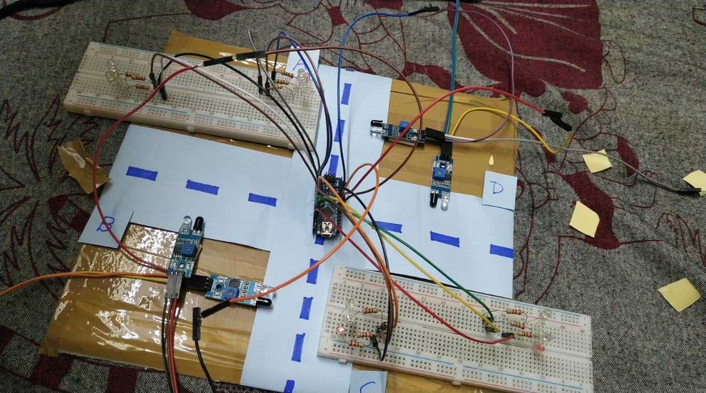

Green led is indicate to run the signal, yellow led indicates to slow the signal , and red led indicates to stop the signal.

#CONDITION 01:

When the traffic status is normal , road B,D,A and C will open respectively.

#CONDITION 02:

When the vehicle is increasing on a certain road, that road is open automatically.

#CONDITION 03:

When the vehicle density is equal on all the road, then the road will be open priority based, which is B,D,A,C respectively.

**9.CONCLUSION:**

JAAR: Volume5, Issue2, June 201793Figure 4 Road 3 Analysesd) Case 4In this case density occurs at road 4 resulting in the green light to go green on road 4 and red light occurs for road 1,road2& road3 respectively. Figure 5 Road 4 Analyses Conclusion .In this research we have worked on Congestion problem for such special areas which have dense traffic density. The system works on traffic related problems such as traffic jam; un reasonable latency time of stoppage of vehicle, emergency vehicles or forcibly passing, etc can be solved. By using this system configuration we try to reduce the possibilities of traffic jams, caused by traffic lights. Number of passing vehicle in the fixed time slot on the road decide the density range of traffics and on the basis of vehicle density calculation, microcontroller decide the traffic light delays.

**9.1CHALLENGES:**

Though the prototype model worked very efficiently with remarkable outputs, the real life situation is going to be way more challenging and demanding. Few of the challenges that should be taken into account are listed as follows

• Low range IR sensors may not be an answer for long range signaling system. We may resort to ultrasound or radar techniques for big scale set-ups.

• Next is the influence of stray signals that may alter the reading of sensor receptors and lead to conveying false information to the microcontroller.

• Periodic checking of the accuracy and precision is a must for efficacious operation of this model prototype

**9.2FUTURE SCOPE**

As the system takes care of few of the drawbacks of the existing system, there is scope for further improvement and expansion of this work. The system can be expanded with smart traffic light control and congestion avoidance system during emergencies emergency cars such as fire engines and ambulances and have priority over other traffic. This system gives highest priority to emergency vehicles to pass them. A development of an intelligent traffic signal control (ITSC) system needed because present traffic light controllers are based on old microcontroller such as AT89C51 which has very less internal memory and no in-built ADC. These systems have limitation because they will use the predefined program that does not have the flexibility of modification on real time application. The approach discussed in above is novel and has achieved the target to control traffic signal system satisfying user needs and requirements. In this project in future i can add module for sensing whose range is more than IR module.

**REFERENCES:**

M. P. Sinhmar, "Intelligent Traffic Light And Density Control Using IR Sensors And Microcontroller," International Journal of Advanced Technology & Engineering Research (IJATER),, vol. VOLUME 2, no. ISSUE 2, 2012.[1] M. P. Sinhmar,"Intelligent Traffic Light And Density Control Using IR Sensors And Microcontroller," International Journal of Advanced Technology & Engineering Research (IJATER),, vol. VOLUME 2, no. ISSUE 2, 2012.

T. Litman, "Congestion Costing Critical Evaluation of the Urban Mbility 2014 Repot," Victoria Transport Policy Institute,Canada, 2014.

B. D. S. Moor, "Optimal traffic light control for a single intersection," International symposium on Nonlinear Theory and its Applications, no. 1997, p. pp. 1085–1088, 1997.

S. Heath, Embedded System Design, India: Elsiever india; Second Edition, 2005.

Federal Highway Administration, Traffic Detector Hand Book, 2006.

G. Padmavathi, D. Shanmugapriya and M. Kalaivani, "A study on vehicle detection and tracking using wireless SensorNetworks," India, 2010.

Intelligent Transport Systems Divition Public Works, ""Technological Research and Development Report on Smart CruiseSystems"," Research Institute of the Ministry of Construction and Advanced Cruise-Assist Highway System ResearchAssociation, vol. Volume 5 in fiscal, no. 1998.

A. K.Vidhya, "International Journal of Innovative Research in Science, Engineering and Technology," Density Based TrafficSignal System , vol. Volume 3, no. Issue 3, 2014 .

L. R. Endar H. Nugrahani1, "Traffic Light Strategies in Optimizing the Traffic Flow," in 2nd IMT-GT regional conference onmathematics, statistics and applications, Malaysia, penang, 2006.

"ELECTRONICS HUB," [Online]. Available: http://www.electronicshub.org/. "Wikipedia,". Available: https://en.wikipedia.org/wiki/Light-emitting_diode